CS F433: Computational Neuroscience
SECOND SEMESTER 2024-25



ASSIGNMENT REPORT:
Hopfield Networks

SUBMITTED BY

NAME | ID NUMBER
Aditya Pentyala | 2022B3A70522H
Hari Charan Budamagunta | 2022A7PS1378H

Table of Contents
Introduction 2
Implementation details 2
Images 3
Test 1: Noisy Image Prediction 4
Asynchronous Updates 5
- Hills 5
- Dragon 6
- Flower 6
Synchronous Updates 7
- Hills 7
- Dragon 8
- Flower 8
Test 2: Incomplete Image Prediction 9
Asynchronous Updates 9
- Hills 9
- Dragon 10
- Flower 10
Synchronous Updates 11
- Hills 11
- Dragon 11
- Flower 12
Test 3: Probabilistic Simulation 13
Inferences 14
Appendix 15
hopfield_network.py 15
Simulation code 19
Conclusion 20

Introduction

Implementation details
Hopfield networks are a primitive form of recurrent neural networks that are capable of retrieving and storing memories. This report details our implementation of a 16x16 hopfield network using NumPy and the results of various tests the network was put through.

We begin by defining utility functions to read .pbm files as 2-D NumPy arrays, to add “noise” to various testing images, and to obscure parts of an image by creating a bounding box, outside of which the image is erased.

Then, a HopfieldNetwork class is created under which methods to load an image, train, and update the network’s state, both synchronously and asynchronously, are defined.

Next, functions to test the model on its predictions are created - one for synchronous and another for asynchronous. Additionally, the synchronous function returns the number of steps and the states through which the network traverses in order to converge. Both functions can plot the intermediate states through which the network passes on its way to convergence.

Finally, to understand the network’s efficacy in predictions, for each image trained on, 20 initializations of the image obscured with noise filters of probabilities 0.2 through 0.9 are predicted upon, and the correctness and number of steps required to converge synchronously are stored. The results of these simulations are then saved and presented graphically.

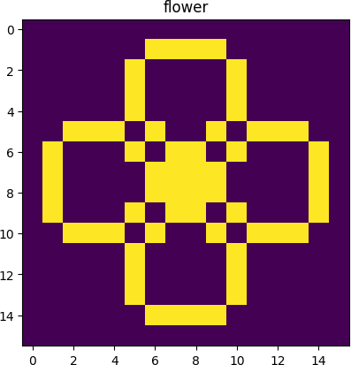
Images
The network is trained on 3 images, as increasing the number of images would result in the network failing to converge to any of the three. Hypothetically, this could be due to the weights interacting in a way such that a new stable state is formed that the model converges to each time.

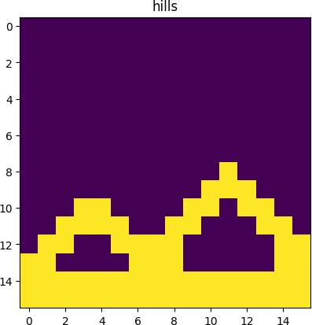
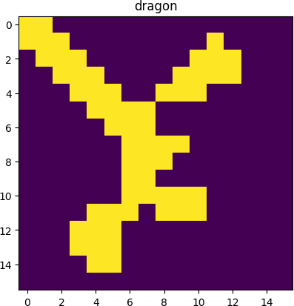
The images are as follows:

Test 1: Noisy Image Prediction

For this test, each of the images the model is trained upon is passed through a noise filter in which the probability of a pixel being flipped from -1 to 1, or vice versa, is 0.3, i.e., 30%. Then, both synchronous and asynchronous methods of prediction are tested. The results are as follows:

Asynchronous Updates
In each of the following graphics, the following plots are present:
- The first row contains the weights matrix visualized
- The second row consists of the distorted/noisy image and beside it, the original image
- The last two rows depict the sequence of states at 100 iteration intervals until 1000 iterations have passed
Note that, under asynchronous updates, the network need not necessarily converge to the original image perfectly, as the pixel that is being updated per iteration is chosen at random and the asynchronous updation runs for a set number of iterations. It is mathematically guaranteed to converge perfectly only for a very large number of iterations, approaching infinity.

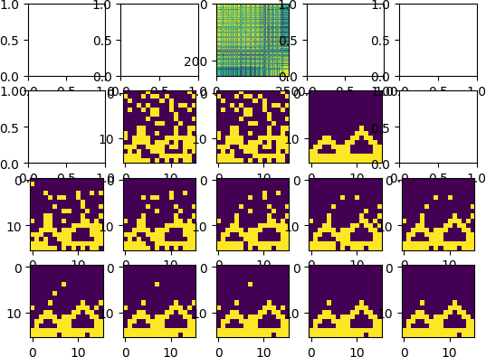
Hills

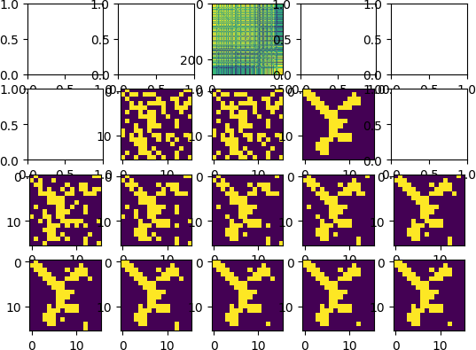
Dragon

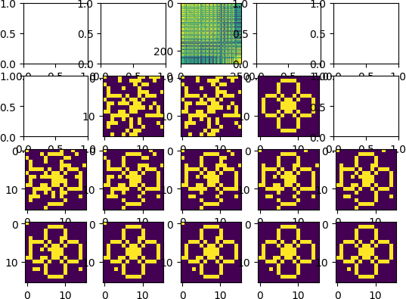
Flower

Synchronous Updates
All synchronous updates converged within a single step, for the p-value of 0.3. The graphics below consist of the following plots:
  - The first row consists of the weights matrix, the distorted image and the original image
  - The second row contains the steps up until convergence (here, a duplicate of the final state is shown to depict convergence)

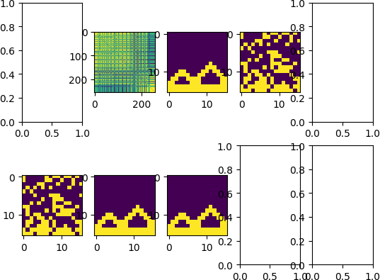
Hills

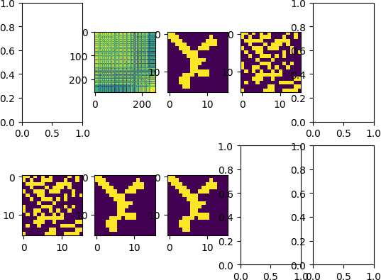
Dragon

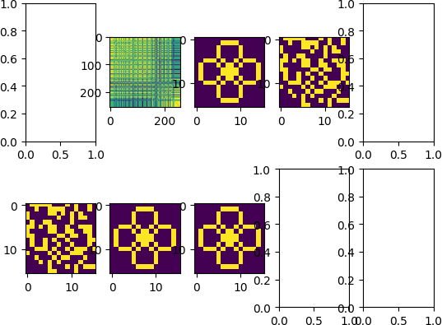
Flower

Test 2: Incomplete Image Prediction

In this test, a bounding box of size 10x10 pixels is overlaid on the image, outside of which all pixel values are set to 0 (not set to -1 or 1 to improve visibility). The results are as follows.

Asynchronous Updates

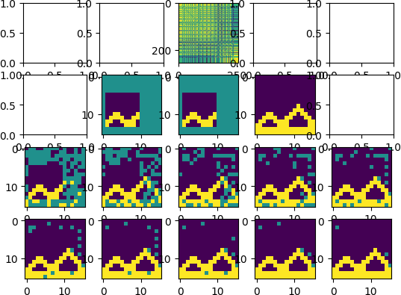
Hills

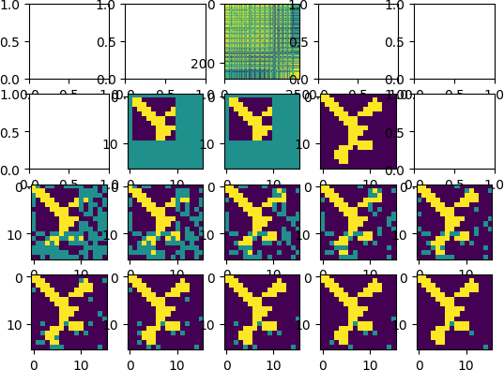
Dragon

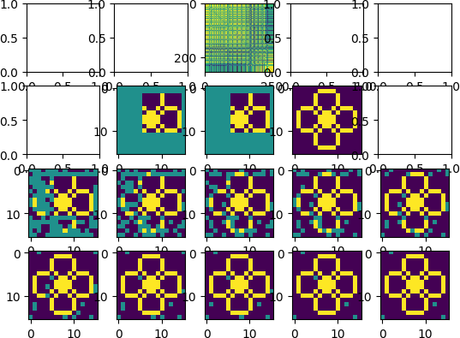
Flower

Synchronous Updates

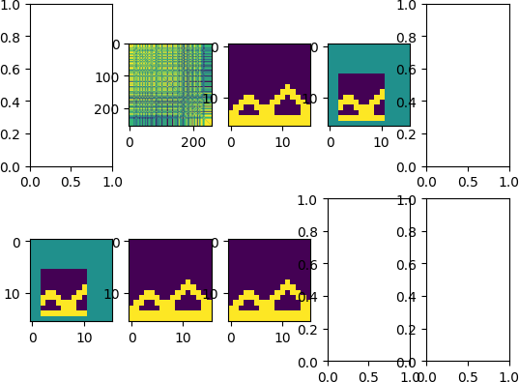
Hills

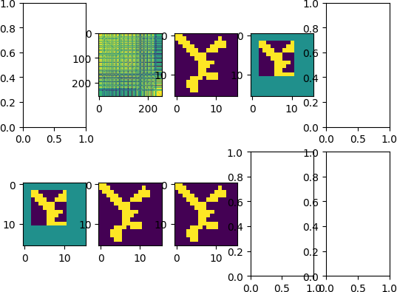
Dragon

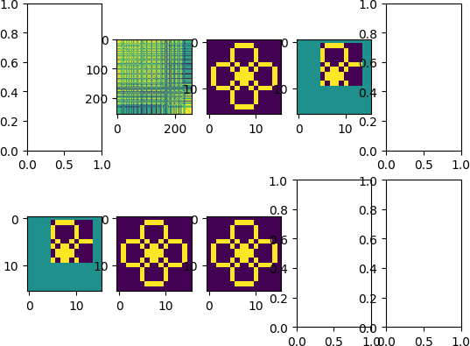
Flower

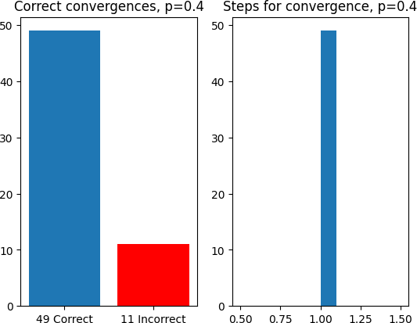
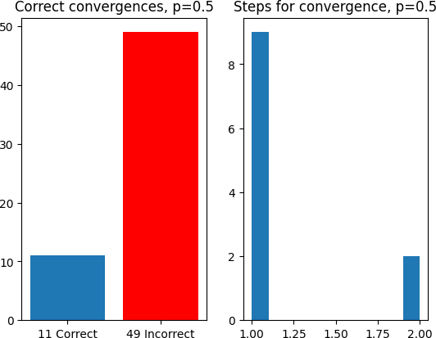
Test 3: Probabilistic Simulation

In this test, for each of the probability values 0.2 through 0.9 in intervals of 10%, for each of the 3 images, 20 different initializations of noise filters are taken and passed to the network to predict upon. The number of correct convergences and steps taken to converge for each of the images are detailed in separate bar charts and histograms per probability value.

Note that, for each of the probability values, a convergence to either the original image or the original’s inverted image, i.e., the 1s being replaced with -1s and vice versa, are counted as “correct”, since at higher probability values of pixel flipping, the network would exclusively converge to the inverted image.

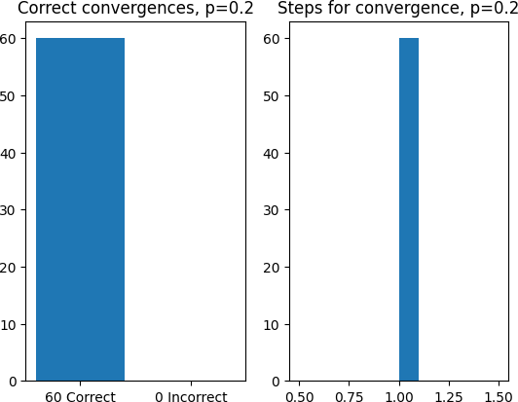
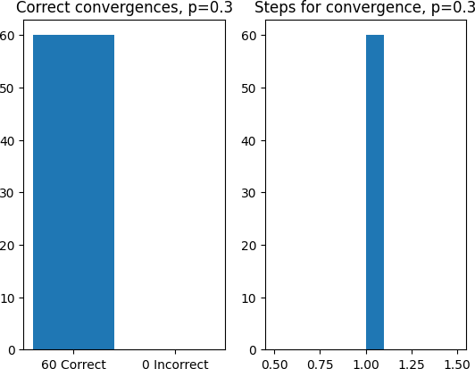
The results of the experiment are given below.

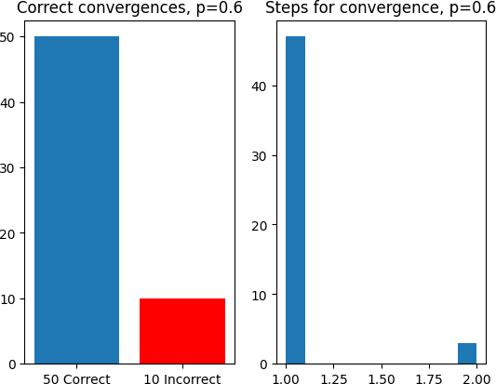
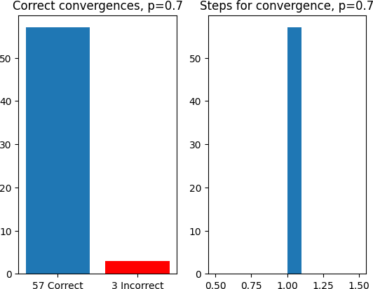

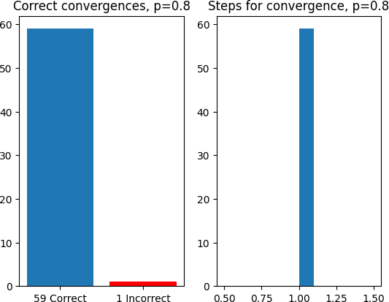
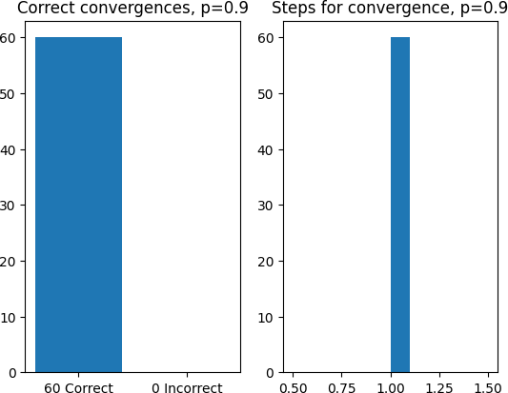
Inferences
We notice that, for probability values nearing the ends of our distribution (i.e., 0.2, 0.3, 0.8, 0.9), an overwhelming majority of the network’s predictions are correct as the original image or the inverted image. The model makes a few mistakes for
0.4 and 0.6, and at value 0.5, it is unable to correctly predict more than 80% of the images fed to it.

The histograms are mostly single columns, since it seldom takes more than a single step to converge to the original/inverted image. Fewer than 10 images faced 2 steps to correct convergence, and none faced over 2.

Appendix
Given below are simply excerpts of the main python file and simulation code from the jupyter notebook. The entire project is available at https://github.com/adityapentyala/hopfield-networks.git.

hopfield_network.py
import os
import numpy as np
from PIL import Image
import matplotlib.pyplot as plt import copy

def read_pbm(path):
data = np.zeros((16, 16))
with open(path, "r") as pbm: row_number = 0
while row_number<16:
row = pbm.readline().split()
if row[0]=="#" or len(row)!=16: continue
#row = ["-1" for i in row if i=="0"] data[row_number] = np.asarray(row)
row_number+=1 pbm.close()
data = np.where(data == 0, -1, data) return data

def create_noisy_image(img, p):
noisy_img = copy.deepcopy(img)
for i in range(noisy_img.shape[0]):
for j in range(noisy_img.shape[1]): if np.random.random() < p:
noisy_img[i][j]*=-1 return noisy_img

def create_bounding_box(img, _type=-1): bounded_img = copy.deepcopy(img)
start_point = (np.random.randint(0, 6), np.random.randint(0, 6))
end_point = (start_point[0]+10, start_point[1]+10) print(start_point, end_point)
for i in range(bounded_img.shape[0]):
for j in range(bounded_img.shape[1]):
if i<=start_point[0] or i >= end_point[0] or j<= start_point[1] or j >= end_point[1]:
bounded_img[i][j] = 0 return bounded_img

class HopfieldNetwork: def init (self):
self.neurons = 256
self.weights = np.zeros(shape=(self.neurons, self.neurons)) self.state = np.random.randint(-1, 2, (16, 16))
self.memories = 0

def train_network(self, train_data): self.memories = 0
for train_img in train_data:
train_img_flattened = train_img.flatten()
self.weights += np.outer(train_img_flattened, train_img_flattened)
np.fill_diagonal(self.weights, 0) self.memories+=1
#self.weights = self.weights/self.memories

def update_state_async(self, theta, n): state = self.state.flatten()
for i in range(n):
x = np.random.randint(0, 256)
activation = np.dot(self.weights[x], state) state[x] = 1 if activation > theta else -1
self.state = state.reshape((16,16))

def update_state_sync(self, theta): converged = False
states = [] steps = 0
while not converged:
prev_state = copy.deepcopy(self.state)
states.append(prev_state)
state = self.state.flatten()
activation = np.dot(self.weights, state)
new_state = np.where(activation >= theta, 1, -1) self.state = new_state.reshape(16, 16)
steps+=1
if (prev_state == self.state).all(): converged=True
states.append(self.state) return steps-1, states

def load_state(self, img): self.state = img

def print_state(self, state=None): if state is None:
state = self.state
for i in range(state.shape[0]):
for j in range(state.shape[1]): print(state[i][j], end=" ")
print()

def print_weights(self):
for i in range(self.weights.shape[0]):
for j in range(self.weights.shape[1]): print(self.weights[i][j], end=" ")
print()

def create_train_data(images): train_data = []
for img in images:
train_data.append(np.reshape(img, (1, 256))) return train_data

def predict_async(hn: HopfieldNetwork, _test_image, noise, p): if noise:
test_image = create_noisy_image(_test_image, p) else:
test_image = create_bounding_box(_test_image)
hn.load_state(test_image)
start_state = copy.deepcopy(hn.state) states = []
for i in range(10):
hn.update_state_async(0, 100)
states.append(copy.deepcopy(hn.state)) fin_state = (hn.state)
f, axarr = plt.subplots(4, 5) axarr[0, 2].imshow(hn.weights) axarr[1, 1].imshow(test_image)
axarr[1, 2].imshow(start_state) axarr[1, 3].imshow(_test_image) for i in range(2, 4):
for j in range(0, 5):
axarr[i, j].imshow(states[(i-2)*5+j]) plt.show()

def predict_sync(hn: HopfieldNetwork, _test_image, noise, p, plot): states = []
if noise:
test_image = create_noisy_image(_test_image, p) else:
test_image = create_bounding_box(_test_image) hn.load_state(test_image)
n, states = hn.update_state_sync(0) if plot:
f, axarr = plt.subplots(2, 5) axarr[0, 1].imshow(hn.weights)
axarr[0, 2].imshow(_test_image) axarr[0, 3].imshow(test_image) for i in range(1, 2):
for j in range(0, len(states)):
axarr[i, j].imshow(states[(i-1)*5+j]) plt.show()
else:
return n, states

if name == " main ":
train_data = []
for path in os.listdir("data/"): if path.split(".")[1]!="pbm":
continue
img = read_pbm("data/"+path) train_data.append(img)

test_image = read_pbm("data/flower.pbm")

train_data = create_train_data(train_data) hn = HopfieldNetwork()
hn.train_network(train_data)

#predict_async(hn, test_image, True, 0.2) predict_sync(hn, test_image, True, 0.2, True)

Simulation code
probabilities = [0.2, 0.3, 0.4, 0.5, 0.6, 0.7, 0.8, 0.9]
foreach_steps = [] corrects = []
for p in probabilities: steps = []
correct = 0
for img in imgs:
for i in range(20):
n, states = predict_sync(hn, img, True, p, False)
if (states[-1] == img).all() or ((states[-1]*-1)==img).all(): correct+=1
steps.append(n) corrects.append(correct)
foreach_steps.append(steps) print(p, " done")

Conclusion

For this assignment, we have successfully implemented a 16x16 hopfield network and tested it on various noisy images with different probabilities such as 0.3,0.4, etc with both asynchronous and synchronous updates.
The network's performance was largely dependent on the level of noise introduced, with higher probabilities of pixel flipping leading to better convergence to either the original or inverted image.

In asynchronous updates, the network showed variability in convergence, because the pixel flippings were random. But for synchronous updates , the network converged within a single step at a noise probability of 0.3. This highlights the advantage of synchronous updating in terms of faster convergence.

It was evident that the network's ability to predict correctly decreased slightly at mid-range probabilities (0.4 and 0.6), while the network continued to perform well at the extreme ends of the probability spectrum.

